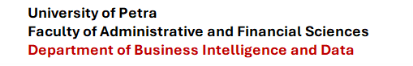

Clicks Loyalty Customer Analytics
and Machine Learning System
Documentation Report
Prepared By:
Faisal Abidy
Armen Balian
Mohammed Al Kouz
Supervised By:
Dr. Ayman Mansour

Course: 307498 – Graduation Project
First Semester, 2025/2027


Declaration of Originality
This document has been prepared as an original documentation report for the Clicks Loyalty Customer Analytics and Machine Learning System. The explanations, analysis, and project structure are written for this project, and the referenced external sources are cited in the References section. All figures and tables are based on the local project files, generated outputs, and charts produced by the standalone pipeline.
The purpose of this declaration is to confirm that the document describes the implemented work honestly and that the technical explanation is connected to the actual code, dataset, model outputs, and generated files.

Acknowledgments
I would like to express my sincere appreciation to everyone who supported the completion of this project. Special thanks are due to the academic staff and project supervisors who provided guidance, feedback, and direction during the development of the analytics and machine learning workflow. Their comments helped improve both the implementation and the documentation quality.
I would also like to thank my colleagues, friends, and family for their encouragement throughout the project. Their support helped make the work more organized, realistic, and complete. Finally, I acknowledge the open-source Python ecosystem, especially pandas, NumPy, matplotlib, and scikit-learn, which provided the tools used to implement the system.

Summary
The Clicks Loyalty Customer Analytics and Machine Learning System is a standalone analytics project built around the updated customers-gp.csv dataset. The system cleans and validates customer data, engineers loyalty-related variables, calculates a loyalty score, ranks customers, assigns business segments, applies KMeans clustering, trains classification models, evaluates a regression model, and exports reports and charts.
The dataset contains 446 customer records with customer names, usernames, points, birthdays, and member-since dates. The dataset was cleaned so that it contains no duplicate names, usernames, point values, or full rows.
The system compares Decision Tree, Random Forest, and Gradient Boosting classifiers. Gradient Boosting is the strongest model in the tests. With the 70 percent training and 30 percent testing split, it achieved 91.04 percent accuracy and 91.16 percent F1 score. The system also uses Linear Regression to predict the continuous loyalty score, producing an RMSE of 10.6890 and an R2 score of 0.5806.
The final result is a practical and explainable customer loyalty analytics workflow. It can support customer ranking, VIP targeting, retention planning, re-engagement campaigns, and future predictive modeling.

List of Abbreviations
AI: Artificial Intelligence
CSV: Comma-Separated Values
EDA: Exploratory Data Analysis
F1: Harmonic mean of precision and recall
IQR: Interquartile Range
ML: Machine Learning
RMSE: Root Mean Squared Error
R2: Coefficient of Determination
KMeans: K-Means Clustering Algorithm
VIP: Very Important Person or high-value customer category

Table of Contents
Declaration of Originality 2
Acknowledgments 3
Summary 4
List of Abbreviations 5
Table of Figures 7
Table of Tables 8
1. Introduction 9
1.1 Overview 9
1.2 Problem Statement 9
1.3 Objectives 10
1.4 Contribution 10
2. Project Plan 11
2.1 Deliverables 11
2.2 Project Tasks 11
3. Requirements Specification 12
3.1 Functional Requirements 12
3.2 Non-Functional Requirements 13
4. Dataset and Preprocessing 14
4.1 Dataset Description 14
4.2 Data Cleaning 13
4.3 Feature Engineering 14
5. System Design and Implementation 15
5.1 Pipeline Design 15
5.2 Ranking and Segmentation 15
5.3 Output Files 16
6. Model Training and Testing 18
6.1 Model Selection 18
6.2 Train-Test Split 18
6.3 Testing Results 18
7. Results and Discussion 20
8. User Manual 21
9. Code Documentation 22
10. Conclusions and Future Work 23
References 24

Table of Figures
Figure 1: Customer points distribution 13
Figure 2: Customer segment distribution 16
Figure 3: Points versus loyalty score 17
Figure 4: Membership duration versus points 17
Figure 5: Gradient Boosting feature importance 19
Figure 6: Gradient Boosting confusion matrix 19
Figure 7: Top 10 loyal customers 20

Table of Tables
Table 1: Dataset validation summary 12
Table 2: Engineered features used in the project 14
Table 3: Loyalty score weighting system 15
Table 4: Customer segment logic and business action 16
Table 5: Model configuration used in clicks.py 18
Table 6: Classification results across train-test experiments 18
Table 7: Linear Regression performance 20

1. Introduction

1.1 Overview
Customer loyalty programs generate valuable data about how customers interact with a business. Points, membership dates, and activity history can reveal which customers are highly loyal, which customers are still developing, and which customers need re-engagement. This project focuses on transforming a simple Clicks customer dataset into a professional analytics and machine learning workflow.
The final system is implemented in clicks.py and uses customers-gp.csv as the input dataset. The script is standalone, meaning it does not require changes to the original project file. It creates new output folders for reports, charts, and model notes so the original outputs remain separated.

1.2 Problem Statement
The original dataset contains only basic customer information: name, username, points, birthday, and member-since date. These fields are useful, but they do not directly explain customer value or loyalty behavior. A business user needs a clearer way to rank customers, identify loyalty groups, understand customer activity, and compare predictive models.
The main problem is therefore to build a complete data analytics system that can clean the dataset, create meaningful loyalty features, segment customers, rank them, and evaluate machine learning models that predict customer segments.

1.3 Objectives
- Clean and validate the updated Clicks customer dataset.
- Create a realistic loyalty score that combines points, ranking, activity rate, and membership duration.
- Rank customers from strongest to weakest loyalty behavior.
- Assign customers into clear business segments with recommendations.
- Use clustering to discover natural customer groups.
- Train and compare classification models for customer-segment prediction.
- Evaluate a regression model for loyalty-score prediction.
- Generate documentation-quality outputs, charts, and model summaries.

1.4 Contribution
The project contributes a structured and explainable customer loyalty pipeline. It adds a Gradient Boosting Classifier as an additional model, compares it against Decision Tree and Random Forest, and documents the ranking system in a way that can be understood by both technical and business readers.

2. Project Plan

2.1 Project Deliverables
The project deliverables include the updated dataset, the standalone implementation file, generated outputs, generated charts, model summaries, and this Word documentation report. The most important deliverable is the enriched customer output, segmented_customers.csv, because it contains the original customer data plus engineered features, loyalty score, segment label, recommendation, outlier status, rank, and cluster.

2.2 Project Tasks
- Create a standalone analytics pipeline with Gradient Boosting integration.
- Validate and clean the customer dataset.
- Engineer loyalty-related features and scoring metrics.
- Segment customers into loyalty categories and generate business recommendations.
- Apply K-Means clustering to discover customer groups.
- Train and compare Decision Tree, Random Forest, and Gradient Boosting models.
- Evaluate Linear Regression for loyalty score prediction.
- Generate reports, outputs, and visualizations.

2.3 Scope
The project scope is limited to customer loyalty analytics using the available CSV dataset. It does not include a web application, database backend, real-time dashboard, or deployed prediction service. However, the generated outputs can support those future extensions.

3. Requirements Specification

3.1 Functional Requirements
- The system shall load the customers-gp.csv dataset.
- The system shall validate the required columns: Customer Name, Username, Points, Birthday, and Member Since.
- The system shall clean numeric point values and date values.
- The system shall calculate engineered loyalty features.
- The system shall calculate a loyalty score and loyalty rank for every customer.
- The system shall assign a customer segment and business recommendation.
- The system shall train Decision Tree, Random Forest, and Gradient Boosting classifiers.
- The system shall evaluate Linear Regression for loyalty-score prediction.
- The system shall export CSV reports and charts.

3.2 Non-Functional Requirements
- The system should be reproducible by using a fixed random state.
- The system should keep generated outputs separate from original project outputs.
- The system should be explainable, especially in the ranking and segmentation logic.
- The implementation should rely on standard Python data science libraries.
- The output files should be readable and useful for both technical review and business interpretation.

3.3 Software Requirements
The implementation uses Python with pandas, NumPy, matplotlib, and scikit-learn. These dependencies are listed in requirements.txt. The project can be run locally after installing these packages.
python3 -m pip install -r requirements.txt
python3 clicks.py

4. Dataset and Preprocessing

4.1 Dataset Description
The dataset contains 446 customer records. Each row represents one customer in the loyalty program. The original fields are Customer Name, Username, Points, Birthday, and Member Since. These columns are enough to build a meaningful loyalty analysis when they are cleaned and transformed correctly.
Table 1: Dataset validation summary
Validation Check | Result
Total customer records | 446
Duplicate customer names | 0
Duplicate usernames | 0
Duplicate point values | 0
Duplicate full rows | 0

The point values range from 0 to 167,439. The mean is 22,273.42 and the median is 9,641, showing that the distribution is right-skewed. This is common in loyalty programs because a smaller number of customers usually hold very high point balances.
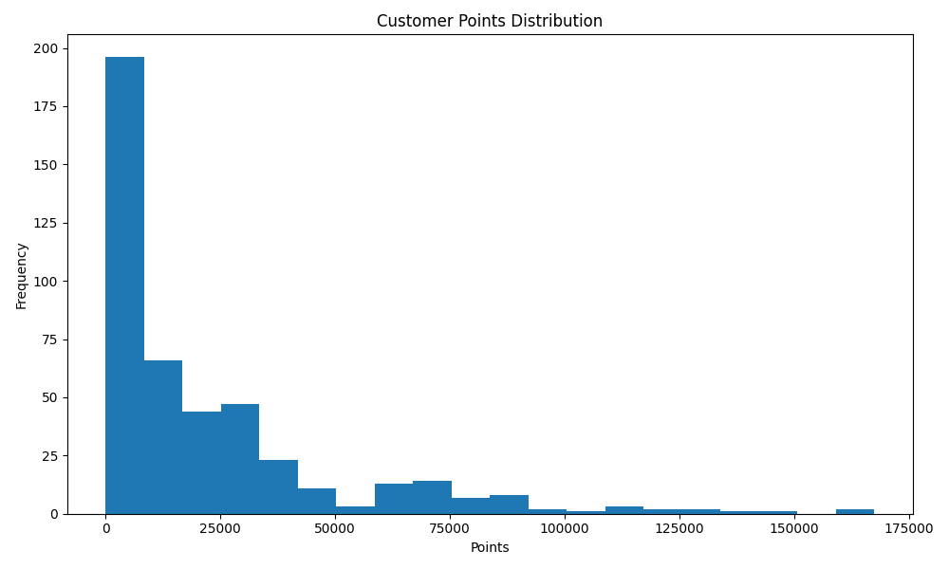
Figure 1: Customer points distribution

4.2 Data Cleaning
The cleaning process begins by normalizing column names. Spaces and slashes are replaced so that columns can be referenced safely in code. The script then checks that all required columns exist. Customer names and usernames are stripped of extra whitespace. Points are converted to numeric values, invalid points are replaced with zero, and negative points are clipped to zero.
Birthday and Member Since are converted into date values using day-first parsing. This is important because the dataset uses a date format such as 14-dec-05. Duplicate rows are removed after cleaning, and the number of removed duplicates is reported by the script.

4.3 Feature Engineering
Feature engineering is the stage that turns the basic dataset into a useful loyalty dataset. The project calculates membership duration, age, transformed point variables, percentile rank, point earning rates, activity status, age group, and membership group. These features make the later scoring and modeling stages more meaningful.
Table 2: Engineered features used in the project
Feature | Purpose
Membership_Days | Measures how long the customer has been in the loyalty program.
Age | Represents customer age based on birthday.
Log_Points and Sqrt_Points | Reduce the effect of very high point values.
Percentile_Rank | Shows where the customer stands compared with all other customers.
Points_Per_Day and Points_Per_Month | Measure earning intensity and recent loyalty activity.
Age_Group and Membership_Group | Support easier reporting and interpretation.

The transformed point features were selected because the point distribution is not balanced. Without transformations, very high point balances would dominate the analysis. Log and square-root transformations help the model understand both ordinary customers and extremely high-value customers.

5. System Design and Implementation

5.1 Pipeline Design
The system is designed as a pipeline. Each function has a specific responsibility: creating folders, normalizing columns, loading and cleaning data, saving reports, engineering features, adding segments, clustering customers, training models, running regression, saving customer outputs, and saving charts. This makes the code easier to review and easier to extend.
- Load and clean the input dataset.
- Generate missing-value and summary reports.
- Engineer features from points, birthdays, and membership dates.
- Scale numeric features and calculate the loyalty score.
- Assign customer segments and recommendations.
- Detect point outliers using the IQR method.
- Sort customers by loyalty score and assign loyalty rank.
- Run KMeans clustering.
- Train and compare classification models.
10.Run Linear Regression and export all reports and charts.

5.2 Loyalty Score and Ranking System
The loyalty score is the center of the system. Before calculating the score, the script scales numeric variables using MinMaxScaler. Scaling is necessary because Points, Membership_Days, Age, Percentile_Rank, and earning-rate features all have different ranges. Without scaling, variables with large numeric values would dominate the formula unfairly.
Table 3: Loyalty score weighting system
Component | Weight | Reason
Points | 35% | Captures total loyalty value.
Log_Points | 20% | Keeps points important while reducing extreme-value distortion.
Percentile_Rank | 20% | Measures relative customer position.
Points_Per_Day | 15% | Rewards earning speed.
Membership_Days | 10% | Recognizes relationship length.

After calculating the loyalty score, the dataframe is sorted from highest score to lowest score. The code then assigns Loyalty_Rank from 1 to the total number of customers. Rank 1 is the strongest customer according to the weighted score, not simply the customer with the highest raw points. This makes the ranking more balanced because it also considers earning speed and customer position within the dataset.
df = df.sort_values(by="Loyalty_Score", ascending=False).reset_index(drop=True)
df["Loyalty_Rank"] = np.arange(1, len(df) + 1)

5.3 Customer Segmentation
The segmentation system converts the loyalty score into business-friendly labels. The script calculates the 20th, 40th, 60th, and 80th percentiles of the loyalty score. Customers are then assigned to Most Loyal, Highly Active, Active, Potential, or Least Loyal depending on where their score falls. Customers with zero points are assigned to Inactive regardless of score.
Table 4: Customer segment logic and business action
Segment | Logic | Business Action
Inactive | Points equal 0 | Launch re-engagement campaign.
Most Loyal | Score >= 80th percentile | Offer VIP rewards and exclusive benefits.
Highly Active | Score >= 60th percentile | Use bonus campaigns and progression offers.
Active | Score >= 40th percentile | Maintain engagement with regular promotions.
Potential | Score >= 20th percentile | Use reminders and point boosts.
Least Loyal | Score below 20th percentile | Use incentives and low-friction offers.

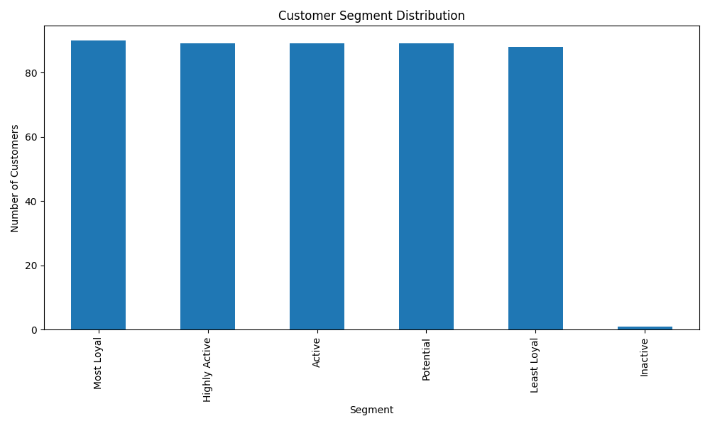
Figure 2: Customer segment distribution
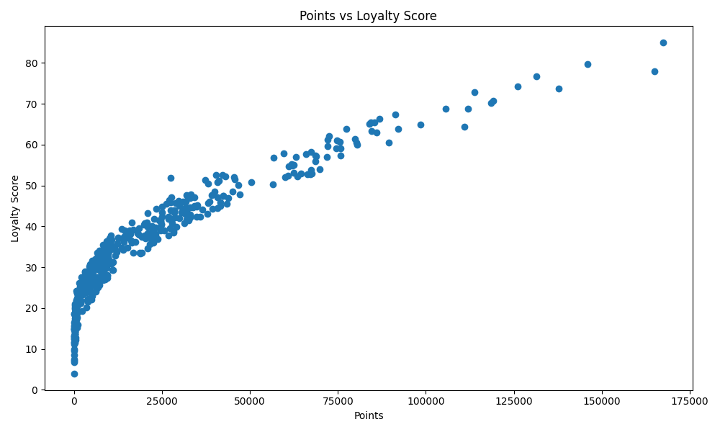
Figure 3: Points versus loyalty score
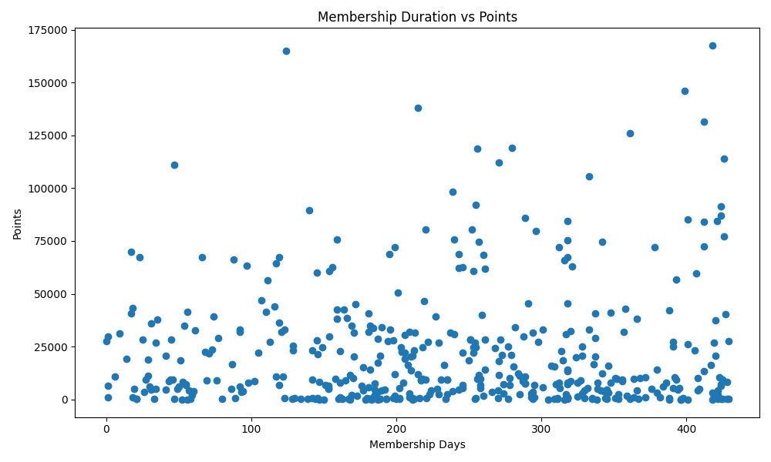
Figure 4: Membership duration versus points

6. Model Training and Testing

6.1 Model Selection
The classification target is Customer_Segment. The model features are Points, Log_Points, Membership_Days, Points_Per_Day, Points_Per_Month, and Age. These features were selected because they are numerical and directly connected to customer loyalty behavior.
Decision Tree was selected as an interpretable baseline. Random Forest was selected because it combines multiple decision trees and improves stability. Gradient Boosting was added as the stronger advanced model because it builds learners sequentially and corrects errors from earlier stages. This makes Gradient Boosting a strong choice for structured tabular datasets.
Table 5: Model configuration used in clicks.py
Model | Configuration | Reason for Selection
Decision Tree | max_depth=3, random_state=42 | Simple baseline with readable rules.
Random Forest | n_estimators=100, max_depth=5, random_state=42 | Stable tree ensemble.
Gradient Boosting | n_estimators=150, learning_rate=0.05, max_depth=3, random_state=42 | Advanced boosting model that learns from previous errors.

6.2 Train-Test Split
A train-test split is used to evaluate how well the model performs on unseen data. Training data is used to fit the model, while testing data is held back for evaluation. The project tested 75/25, 80/20, and 70/30 classification splits. The 70/30 split was selected in the current script because it provides the largest testing set and produced the best Gradient Boosting result.
The script also uses stratification when possible, meaning the distribution of customer segments is preserved between the training and testing sets. This is important because the target variable contains multiple segment classes.

6.3 Testing Results
Table 6: Classification results across train-test experiments
Model | F1 at 75/25 | F1 at 80/20 | F1 at 70/30 | Best Accuracy | Best F1
Gradient Boosting | 0.894183 | 0.891494 | 0.911643 | 0.910448 | 0.911643
Random Forest | 0.876148 | 0.870112 | 0.881902 | 0.880597 | 0.881902
Decision Tree | 0.799510 | 0.806603 | 0.810608 | 0.805970 | 0.810608

Gradient Boosting performs best across all tested splits. This consistency supports the conclusion that it is the strongest classification model for this dataset. The model reached 91.04 percent accuracy and 91.16 percent F1 score using the 70/30 split.
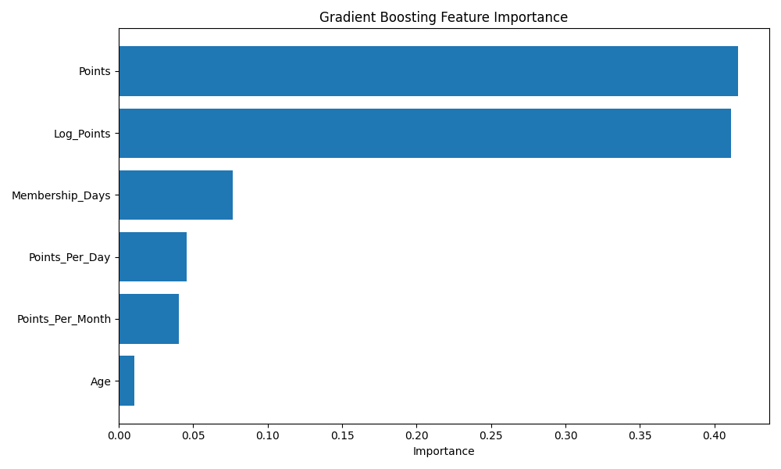
Figure 5: Gradient Boosting feature importance
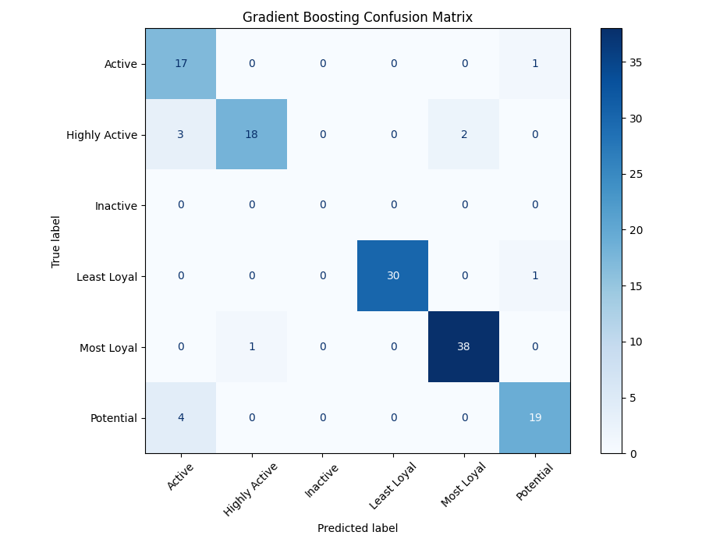
Figure 6: Gradient Boosting confusion matrix

7. Results and Discussion
The results show that the project successfully turns a simple dataset into a full loyalty analytics system. The segmentation output produces balanced groups for the main customer categories. The ranking system identifies the strongest customers for VIP campaigns and the weakest customers for re-engagement efforts. The clustering output provides an additional view of customer behavior that is independent of the rule-based segments.
The feature importance results show that Points and Log_Points are the strongest predictors. This is expected because the segment labels are based mainly on loyalty behavior. Membership_Days and point-rate features also contribute, while Age has a small effect. This is a positive result because the model is mostly using customer activity rather than unrelated demographic information.
The regression model predicts Loyalty_Score with an RMSE of 10.6890 and an R2 score of 0.5806. This means the linear model explains about 58.06 percent of the loyalty-score variation. It is a useful baseline, but future versions could test nonlinear regression models such as Random Forest Regression or Gradient Boosting Regression.

Table 7: Linear Regression performance
Metric | Value | Interpretation
RMSE | 10.6890 | Average error is about 10.69 loyalty-score points.
R2 Score | 0.5806 | The model explains about 58.06% of the score variation.

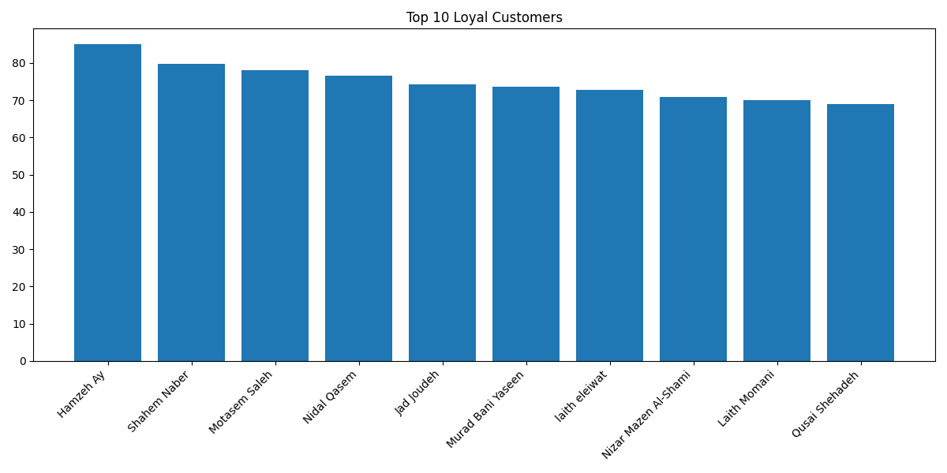
Figure 7: Top 10 loyal customers

8. User Manual
To run the project, open the project folder and install the required packages from requirements.txt. The required libraries are NumPy, pandas, matplotlib, and scikit-learn. After installation, run clicks.py. The script will create the outputs/clicks, charts/clicks, and models/clicks folders if they do not already exist.
python3 -m pip install -r requirements.txt
python3 clicks.py
After execution, the most important output files are segmented_customers.csv, classification_model_comparison.csv, segment_summary.csv, cluster_profile.csv, top_loyal_customers.csv, bottom_customers.csv, and linear_regression_metrics.csv. The most important chart files are the points histogram, segment distribution chart, loyalty scatter plots, feature importance chart, and confusion matrix.

9. Code Documentation
The code is organized into functions so that each part of the workflow is clear. ensure_directories creates the output folders. normalize_columns standardizes column names. load_and_clean_data reads and cleans the dataset. save_basic_reports exports missing-value and summary-statistics reports. add_engineered_features creates membership, age, point transformation, point-rate, and group features.
add_segments calculates score thresholds, assigns segment labels, adds recommendations, detects outliers, sorts customers by loyalty score, and creates Loyalty_Rank. run_clustering applies KMeans and exports cluster profiles. split_classification_data prepares the features and target for classification. evaluate_classifier trains each model, calculates evaluation metrics, saves classification reports, saves confusion matrices, and saves feature-importance files when available.
run_classification_models defines and compares Decision Tree, Random Forest, and Gradient Boosting. run_regression_model evaluates Linear Regression for Loyalty_Score prediction. save_customer_outputs exports the final enriched customer dataset, top customers, bottom customers, segment summaries, and membership summaries. save_charts generates the visualizations used in the documentation.
The main function connects all of these pieces into one complete workflow. This design makes the system easier to maintain and easier to expand later with new models, new features, or a dashboard interface.

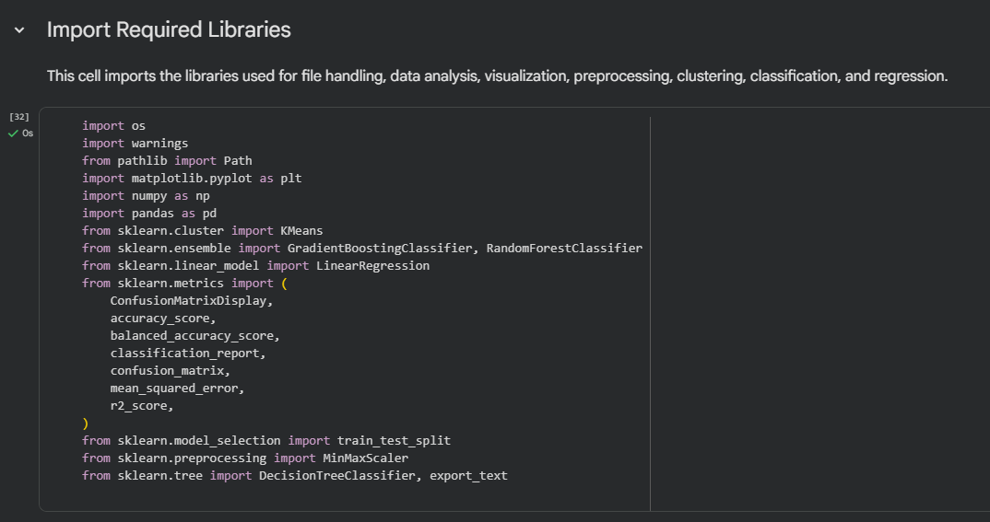
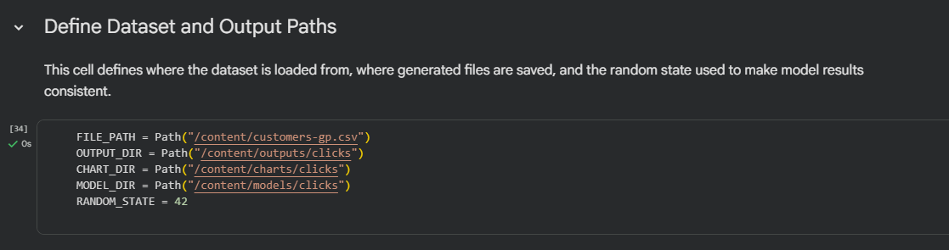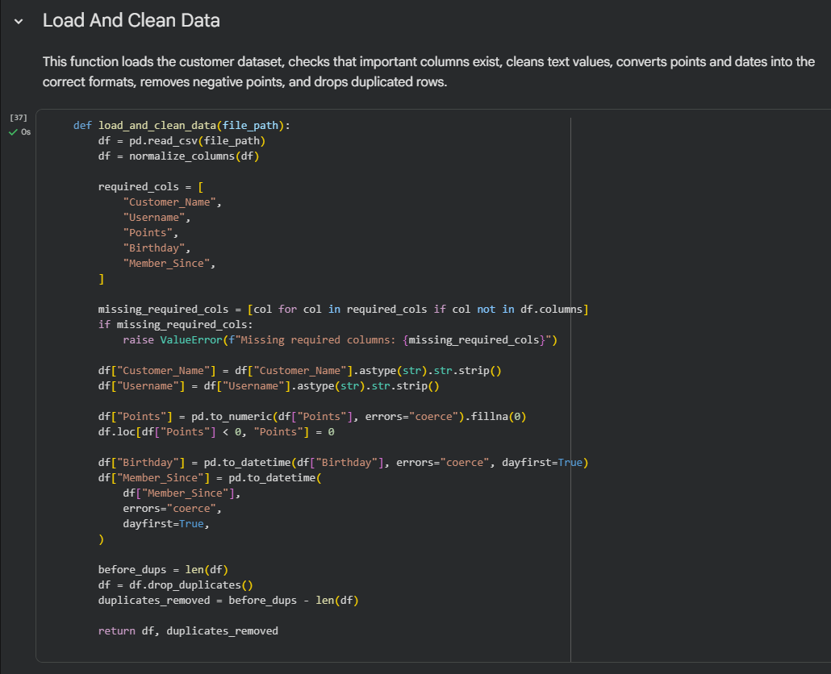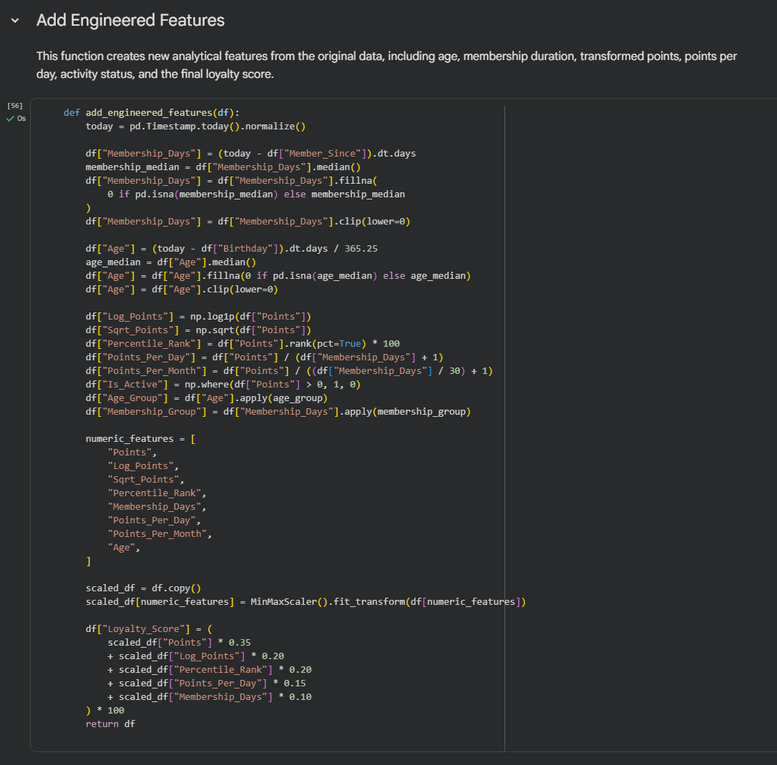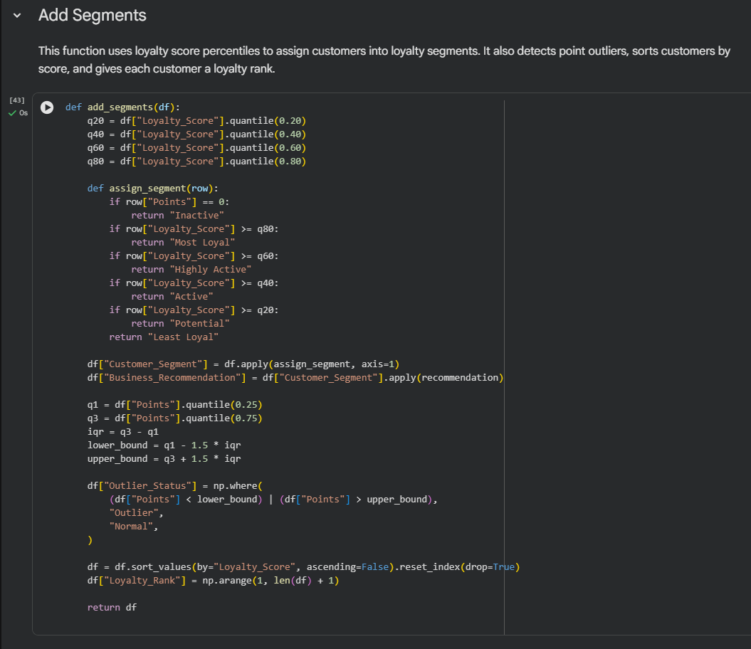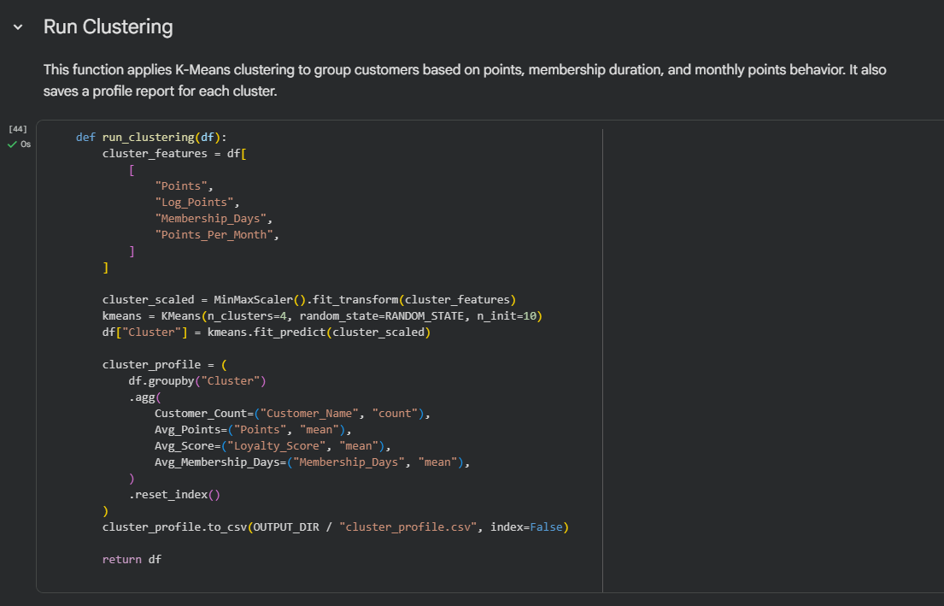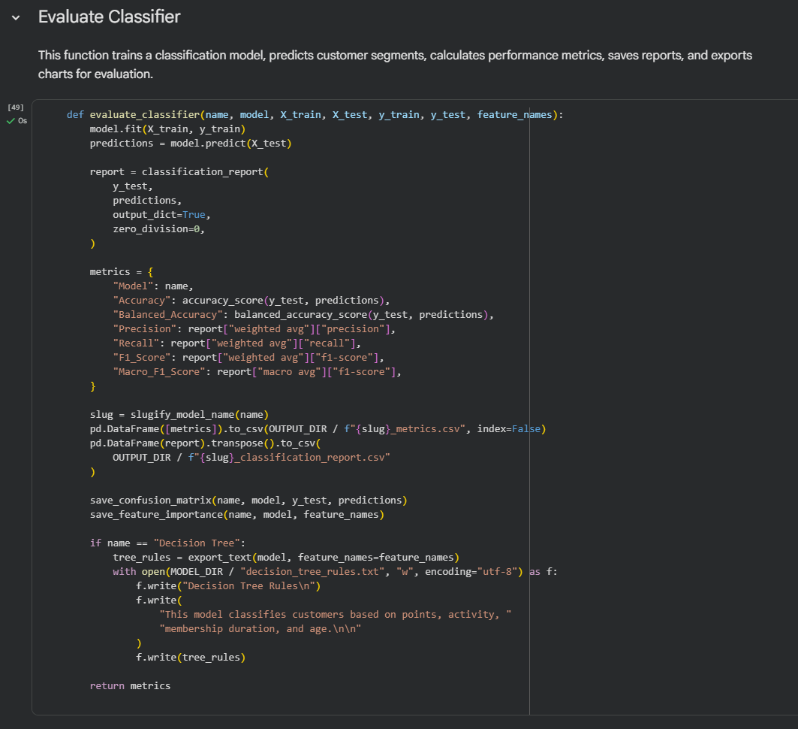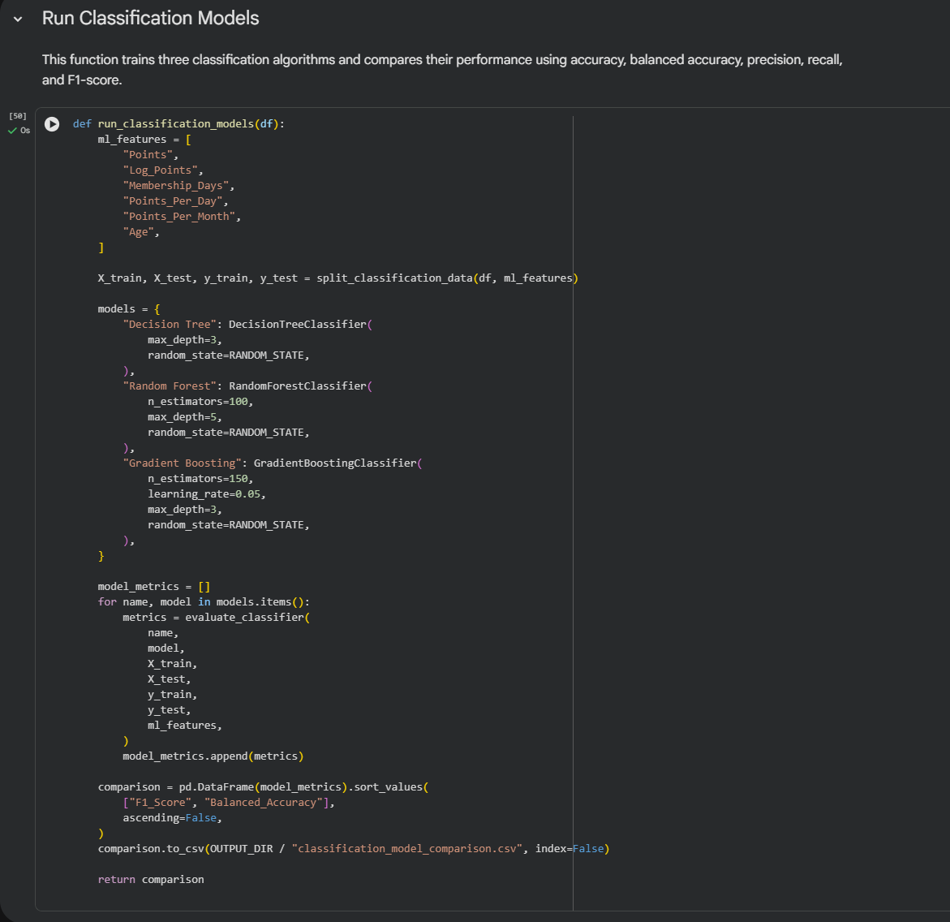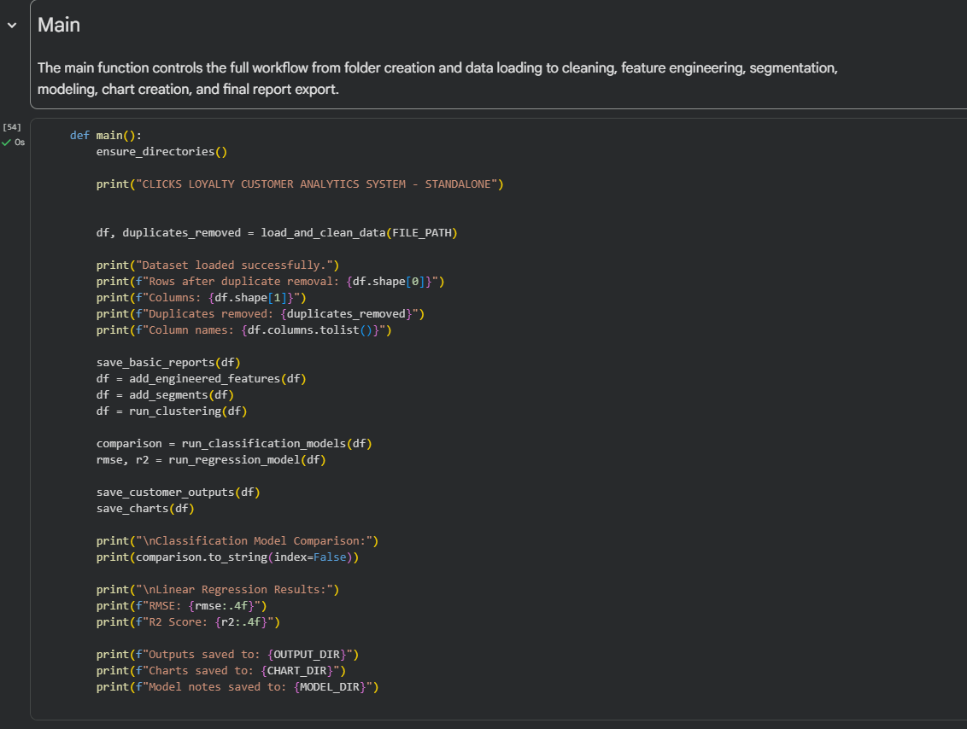

10. Conclusions and Future Work
The Clicks Loyalty Customer Analytics and Machine Learning System provides a complete and explainable analytics workflow for customer loyalty data. It cleans the dataset, engineers useful features, calculates a weighted score, ranks customers, assigns segments, clusters customer behavior, trains machine learning models, evaluates regression performance, and exports usable reports and charts.
The best classification model is Gradient Boosting. It performed better than Random Forest and Decision Tree across all tested train-test splits. The selected 70/30 split produced the strongest Gradient Boosting result, with 91.04 percent accuracy and 91.16 percent F1 score.
Future work should add transaction-level features such as purchase frequency, total spending, last purchase date, coupon usage, product category preferences, and campaign response. The project could also be improved with cross-validation, saved trained models, regression ensembles, and a dashboard for non-technical users.

References
[1] pandas read_csv documentation. https://pandas.pydata.org/pandas-docs/stable/reference/api/pandas.read_csv.html
[2] scikit-learn train_test_split documentation. https://scikit-learn.org/stable/modules/generated/sklearn.model_selection.train_test_split.html
[3] scikit-learn MinMaxScaler documentation. https://scikit-learn.org/stable/modules/generated/sklearn.preprocessing.MinMaxScaler.html
[4] scikit-learn KMeans documentation. https://scikit-learn.org/stable/modules/generated/sklearn.cluster.KMeans.html
[5] scikit-learn DecisionTreeClassifier documentation. https://scikit-learn.org/stable/modules/generated/sklearn.tree.DecisionTreeClassifier.html
[6] scikit-learn RandomForestClassifier documentation. https://scikit-learn.org/stable/modules/generated/sklearn.ensemble.RandomForestClassifier.html
[7] scikit-learn GradientBoostingClassifier documentation. https://scikit-learn.org/stable/modules/generated/sklearn.ensemble.GradientBoostingClassifier.html
[8] scikit-learn LinearRegression documentation. https://scikit-learn.org/stable/modules/generated/sklearn.linear_model.LinearRegression.html
[9] scikit-learn classification_report documentation. https://scikit-learn.org/stable/modules/generated/sklearn.metrics.classification_report.html
[10] scikit-learn r2_score documentation. https://scikit-learn.org/stable/modules/generated/sklearn.metrics.r2_score.html

